**Let's Get Started, Coder!!**

**Fill the following Document**

**__________________________________________________________________________**

1. Which one of the following is an Imperative Language?

1. HTML
2. CSS
3. Java Script

Answer:

Java Script

2. Which one of the following is a Declarative Language?

1. HTML
2. CSS
3. Java Script

Answer:

HTML

3. Name two uses of a DIV tag?

Answer:

* + - 1. The div tag is used in HTML to make divisions of content in the web page.
      2. It is used to the group of various tags of HTML so that sections can be created and style can be applied to them.

4. What is the difference between relative positioning and absolute positioning in HTML?

Answer:

|  |  |
| --- | --- |
| Relative positioning | Absolute positioning |
| The element is positioned relative to its normal position. | **The element is positioned absolutely to its first positioned parent.** |

5. What is the use of opacity in CSS?

Answer:

The opacity CSS property sets the opacity of an element. Opacity is the degree to

which content behind an element is hidden. It is the opposite of transparency.

6. Which is the programming language used in the React Native Framework?

Answer:

JSX = JavaScript XTML

7. Which online editor are we using for creating our apps in React Native Framework?

Answer:

Snack online editor provided by Expo.

8. Write the steps to test your first designed app in the online editor on mobile.

Answer:

Open Expo.dev.

In the Navigation pane on the left side of the website select the snack online editor. A new website will open.

In the main area you will see your projects/games which you made. Click on your first designed game. Your code for the game will be opened.

In the preview area you will see four options – My Device, iOS, Android and Web.

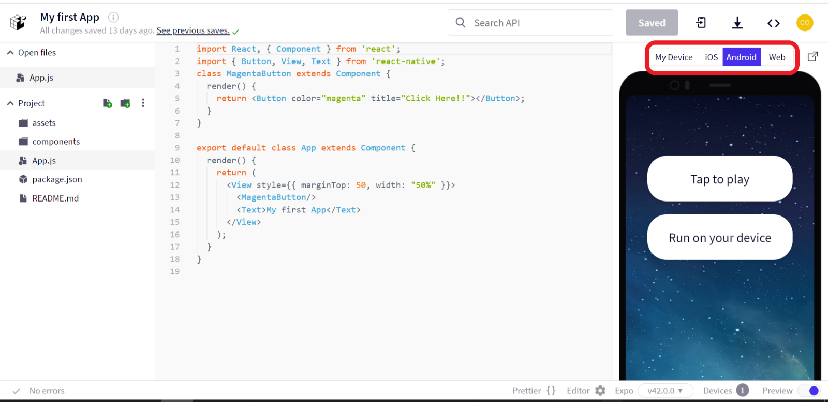

If you want to see how your output will be displayed on iOS/Android click on iOS/Android option. Then click on “Tap to play”.

If you want to link another device to see this output, select My Device option. After selecting a QR code will be generated.

Then, download ‘Expo Go’ on the device in which you want to see the output.

Scan the QR code from the device using Expo Go. Your device is connected to the output of this code of your game.

9. What is the use of the render function in React Native Framework?

Answer:

The purpose of render function is to display the specified HTML code inside the

specified HTML element.

10. What is the use of the return function in the React Native Framework?

Answer:

The return function in the React Native Framework let you describe what you want to

see on the screen.

11. What are the various components in your first app that you designed?

Answer:

There are two components in my first app that I designed. They are: -

The text – “My first app”.

A button naming “Click Here!!”.